**Activity: Analyze in Excel**

**Introduction**

You've just put the final touches on a new Microsoft Power BI report at Adventure Works. The crisp visuals and interactive charts reflect the company's financials across various continents, countries, and regions. Feedback from your boss is that the colorful visualizations are helpful, but she needs to dive deeper. She's preparing for a crucial board meeting where every visual and number must be perfect. In meetings like these, she prefers Excel and wants to know if there's a way to explore the report further in Excel. Your knowledge of the **Analyze in Excel** feature in Power BI saves the day!

In this activity, you'll learn how to open Power BI data in Excel.

**What is Analyze in Excel?**

The **Analyze in Excel** function is a powerful feature in Power BI that allows you to explore your Power BI data in Excel. This way, you get the best of both worlds–the interactive, visual capabilities of Power BI and the flexibility, familiarity, and depth of analysis possible with Excel. It provides a live connection from an Excel **PivotTable** to the data in Power BI. This means that when the data in Power BI is updated, the user can simply refresh their Excel report to see the new data.

**Using the Analyze in Excel feature**

Follow the step-by-step instructions below to open your data in Excel.

**Step 1: Access the Power BI Service**

* Open your preferred web browser. Type **app.powerbi.com** in the address bar and press **Enter**.

**Note:** This action takes you to the Power BI Service's home page. The **Analyze in Excel** feature is only available in Power BI Service, not in Power BI Desktop. Power BI Service offers numerous advantages over its desktop counterpart, including sharing reports across your organization, setting up data alerts, and **Analyze in Excel**.

**Step 2: Navigating to your Workspace**

1. Once on the Power BI Service home page, locate the vertical navigation bar on the left.
2. Select the **Workspaces** icon.

**Note:** This icon looks like multiple windows stacked together, symbolizing the collaborative nature of workspaces.

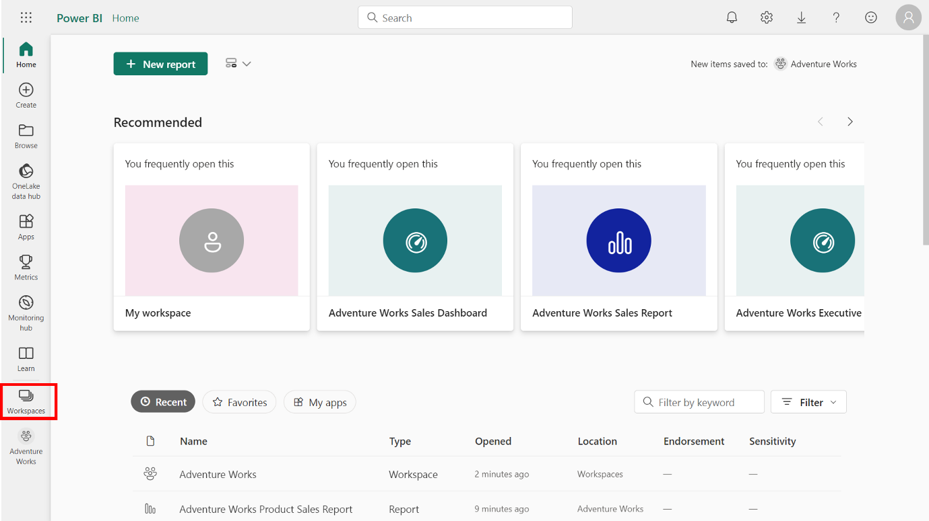

1. Select the **Adventure Works** workspace option, which you created in a previous activity, from the available workspace options.

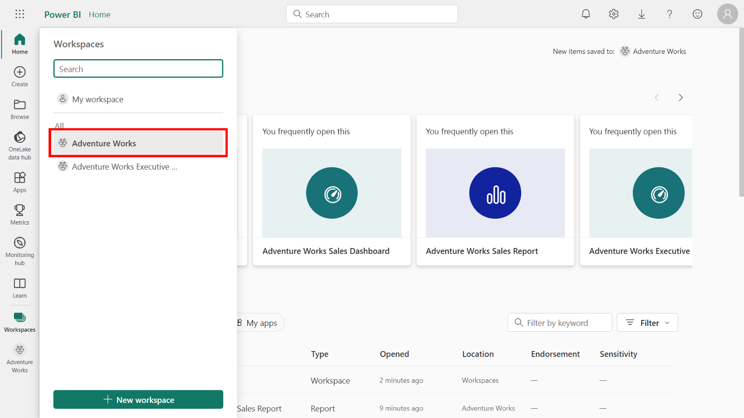

**Step 3: Find your report**

Your dashboards, reports, and datasets are displayed within your workspace. The reports are the ones you've developed and published from Power BI Desktop.

* Find the *Adventure Works Product Sales Report* report and select the **ellipsis** (three horizontal dots) next to it.

**Note:** This **ellipsis** is a common user interface element representing additional options or actions

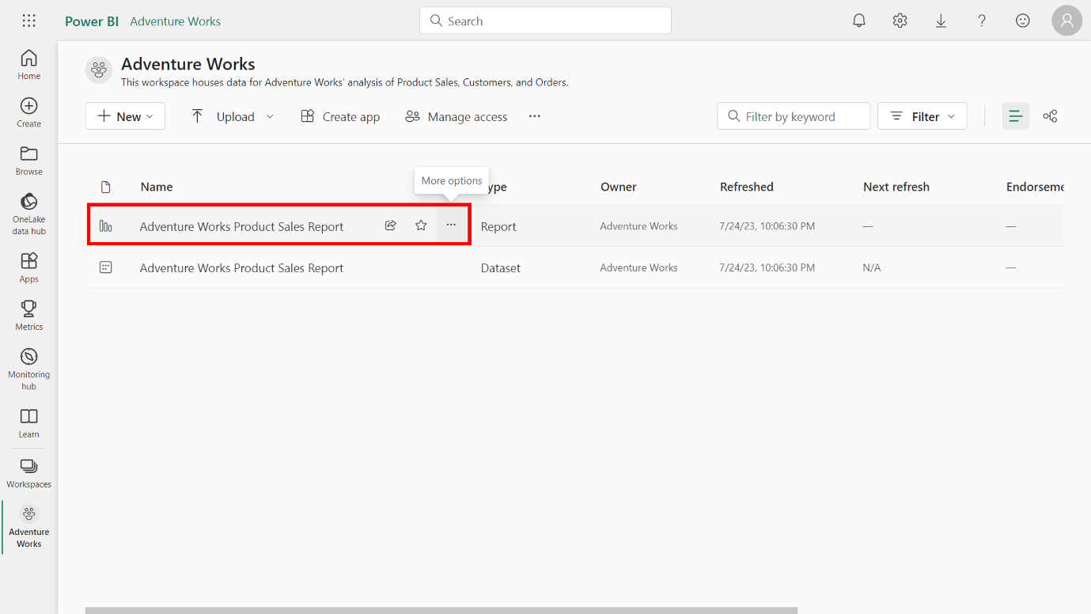

**Step 4: Select Analyze in Excel**

A drop-down menu appears when you select the **ellipsis** next to the Adventure Works Product Sales Report. This menu includes several options, such as **Quick Insights**, **View Lineage**, **Analyze in Excel**, and more.

* Select the **Analyze in Excel** option.

**Note:** This option is specifically designed to let you examine your Power BI data in Excel, offering you the extensive, flexible analytical capabilities that Excel is known for.

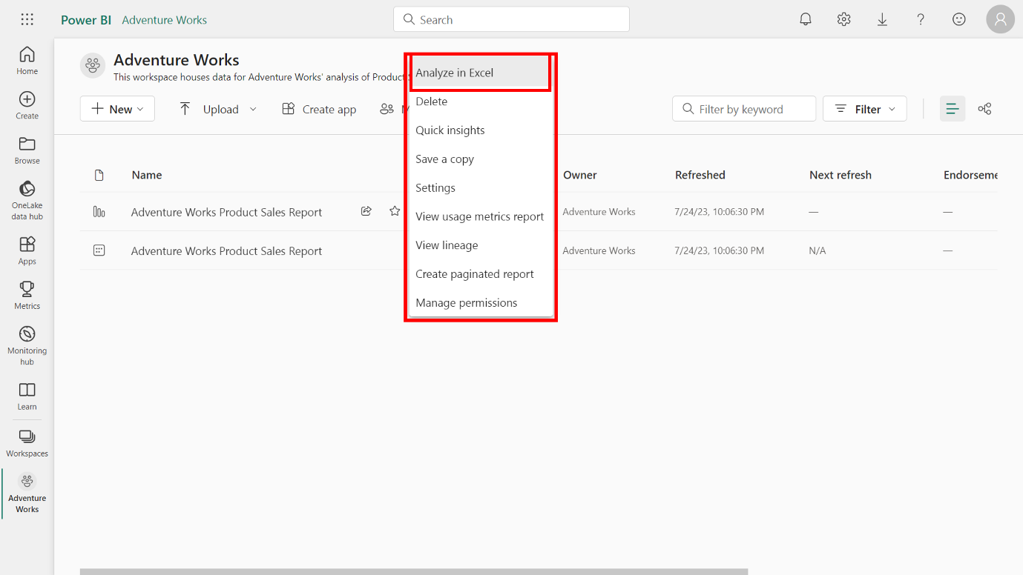

**Step 5: Launch Excel**

* After you select **Analyze in Excel**, Power BI generates an Excel workbook and saves it to your OneDrive SharePoint account.

**Note:** It has the same name as the Power BI report so that you can open the workbook directly in Excel for the web. If you don't have a OneDrive SharePoint account, Power BI prepares a copy of your data and downloads the Excel workbook to your local computer.

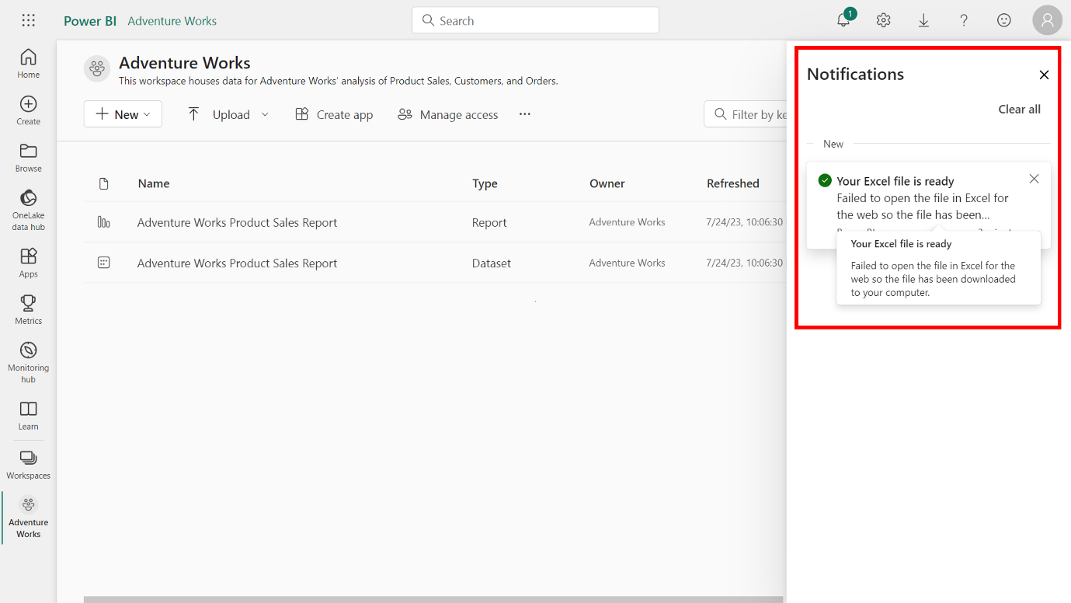

**Step 6: Explore your data in Excel**

With the file opened, an Excel workbook containing a PivotTable will display. This PivotTable holds a live connection to your Power BI dataset, meaning you can manipulate and analyze your data as you would with any other Excel file.

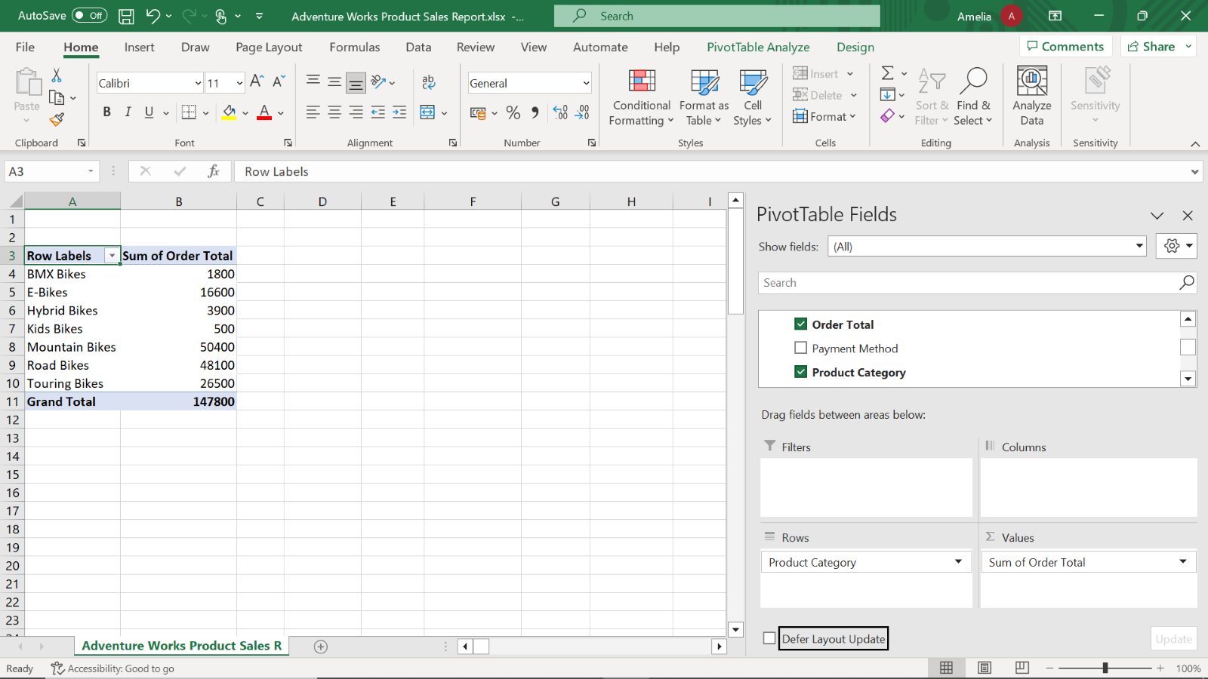

You have now successfully guided your boss through the process of opening a Power BI report in Excel using the **Analyze in Excel** feature!

**Conclusion**

The combination of Power BI's dynamic data visualization and Excel's analytical depth is a powerful combination that can elevate Adventure Work's data-driven decision-making process. You've experienced first-hand how seamless and intuitive it is to analyze your data from Power BI in Excel. The PivotTables and Excel's familiar interface enable you to dive deep into the numbers, making sense of the data. By utilizing the **Analyze in Excel** feature, you're not just opening an Excel spreadsheet; you're opening a portal to deeper insights and better-informed decision-making.